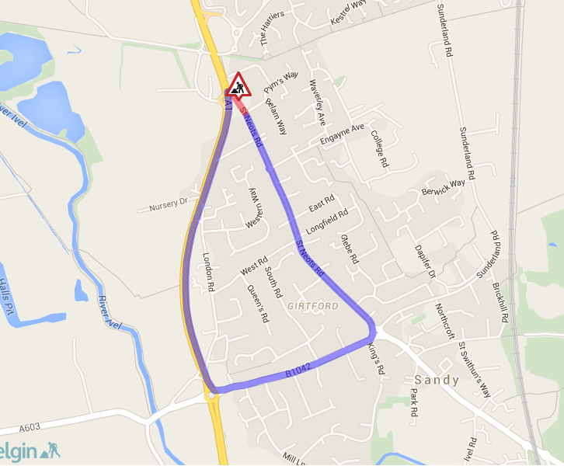

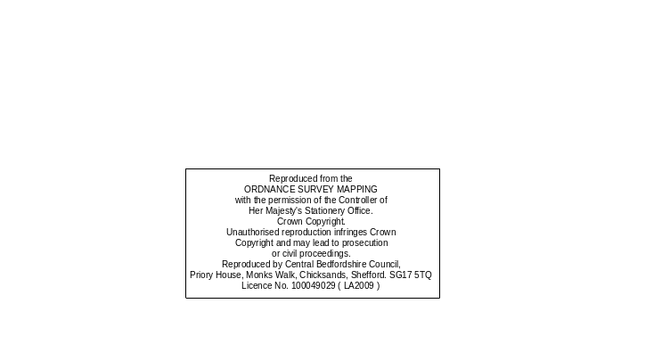

Key

Drawing No
Project Name
Drawing Title
Original Drg Size :
Scale :
Dimensions :
A4
Rev
Revision details
Date:
Drawn:
Chkd:
Appd:
Design:
Rev
As constructed
For construction
For tender
For comment
Chkd
Appd
Date
Preliminary
c
Copyright Amey/CBC
Other
St Neots Rd, Sandy
Proposed Temporary Road Closure
CBC5598
Bedfordshire Highways -
Extent of closure and diversion
Not to scale
-

-
GH
GH
GH
GH
07/07/2015
Diversion Route
Road Closure
Vandyke Roa

