Presented by Let’s Get Going, Sandy Centre Group and Sandy Town Council
Sandy Easter Trail & Quiz 2021
12-16 year olds
Name:

Age:

Parent email address:
Parent contact number:

Aim of the game: Follow the clues and walk or run around the trail, answering the quiz questions on this form. When you have completed the quiz, email it to admin@sandytowncouncil.gov.uk

Deadline is 7th April!
There are prizes for 1st, 2nd and 3rd place, judged on the most correct and creative answers. Good luck!
Starting place: The High Street Community Stand (outside the Post Office)
This route follows the Sandy Green Wheel - a map is available here.

1. Carefully cross Pleasant Place, walk past the car park and turn left to go up to Cambridge Road.
How old is the building where Sandy Town Council’s office now is? What did it used to be?

2. Which road is opposite these signposts?
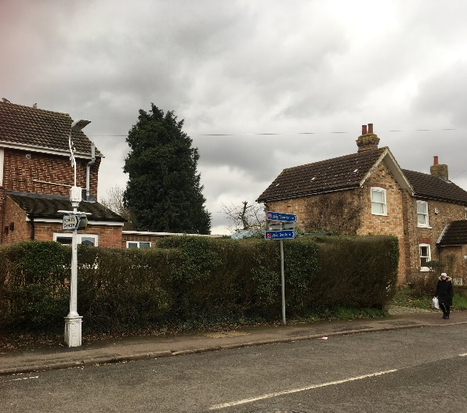

3. Keep going up Cambridge Road. Find this signpost; what object is to the left of this picture? 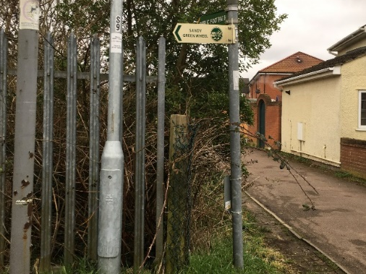
Turn around and walk along Brickhill Road. Near the end of the road, turn right, up a small hill, and cross over the railway bridge.

4. Walk a little way alongside the track (the railway should now be on your left). When you get to this gate which crosses the path, how many horizontal bars are there?
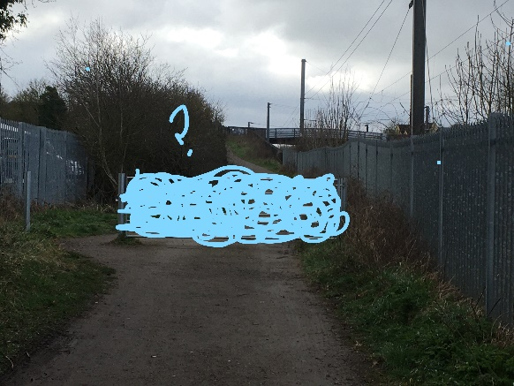

Walk around the side of the gate and keep going.

5. The next metal object on your right looks like this. There are some flowers just in front, what type of flowers are they?
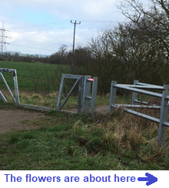

6. As you walk along the track, on the left-hand side are some boxes that have messages on.
Who are they from?
a) The postman
b) An IMP
c) An Elf

7. Keep going all the way along the path until you get to the green foot bridge over the railway.
When you get to the top of the bridge stand with the solar panels behind you. What do solar panels do?

8. If you could take anybody in the world on a special train journey, somewhere they really wanted to go, where would it be and why?

9. Go across the bridge, what is the name of the first factory you see?

Head down the stairs from the bridge and walk along the track to meet the road.

10. Cross over the road carefully and head straight along as if you were going to the A1.
What object is in front of this building?
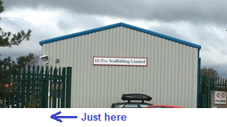
11. What could happen in or on a dome like this? Let your imagination run wild….

When you reach the first roundabout, carefully cross the roads to walk along the grass verge by the side of Sunderland Road, heading towards the A1. There should be a steep grass bank and houses to your left and open fields across the road on your right. You may see stickers on some lampposts showing that you are on the Sandy Green Wheel.

At the 2nd roundabout, keep left (1st exit).

At the 3rd roundabout, cross over the road which leads towards the co-op and follow the paved footpath, continuing towards the A1 (2nd exit).

12. When you get to this sign, what object is behind you?

At the 4th & 5th roundabouts, continue to follow the paved footpath around to the left (1st exits) and then walk under this A1 bridge.
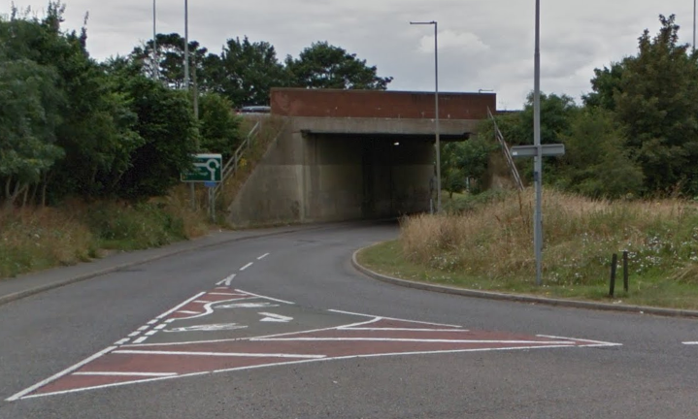

Cross at the last roundabout to go straight over (2nd exit) taking the national cycle route towards Blunham and Bedford.

13. What is the name of the business by the sign for the cycle path towards Bedford?

Continue along the path towards Bedford and follow the signs for the Sandy Green Wheel. This section of the route is straight for a long way.
14. How would you have travelled down this path 100 years ago?

When you get to this gateway, continue straight and pass through it, leaving the hard-surfaced road, which turns off to the right.
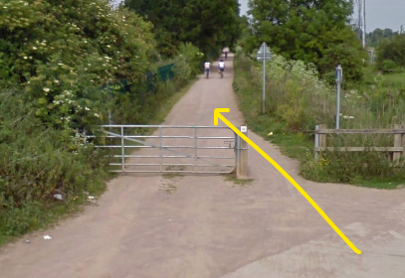

Eventually, the path goes downhill to a crossroad. You’ll see a signpost on the right hand side – this shows you should turn left to stay on the Sandy Green Wheel. Take this left turn onto a gravel path and follow it all the way until you reach a small road.

15. Near the end of the gravel path is a map of the Sandy Green Wheel. What does this tell you that the area behind you is called?

16. Turn left and walk towards the big green buildings – be careful of vehicles, including lorries which may come down the road. What is the name of this business?

17. Which countries’ flags are on the ‘no parking’ sign on this road?

Continue straight on, past the transport office and onto the grass where the footpath begins again. There is a public footpath sign and a Sandy Green Wheel sticker pointing in the right direction.
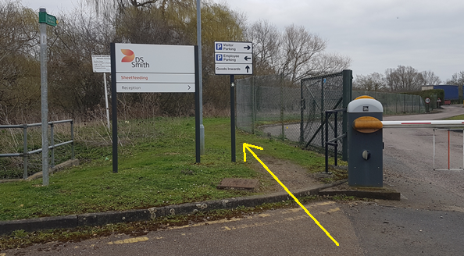

Follow the footpath past the weir and cross the bailey bridge. When you come off the bridge, turn right and follow this winding path all the way along the river. While you are walking with the river on your right hand side, listen, what can you hear?

18. Imagine you turn the corner, and you see the figure of a person in front of you, then you hear a splash. Something has just dropped into the river. They turn quickly as they hear you approach. They were startled to see you. Continue the story.....

Eventually you will come to the side of a brick road bridge (the A603). Turn left, through a wooden gateway and follow this path along and to the right, to cross the road safely.

On the other side of the road, turn right and walk along the pavement and over the footbridge. Continue to follow this path which curves around to the left. Look out for a wooden bridge on your left, and cross this to enter the Riddy nature reserve.

Follow the footpath across this field and, turning right, along the river and under the A1. On the other side of the underpass, look for the small wooden cattle bridge to your right, which crosses the small stream, or ‘riddy’, for which the nature reserve is named. Cross this bridge and make your way back to the path alongside the river, turning right to walk towards the millpond.

19. Go through the gate to leave the Riddy. Turn around to see what kinds of wildlife lives in the nature reserve. Which semi-aquatic mammal might you hear entering the water with a ‘plop’?

Walk left towards the bench – a good spot to watch the swans on the millpond. At the grass triangle, turn right to walk along the raised footpath beside the river, and all the way to the end of Ivel Road.

Turn left and walk all the way up Ivel Road to the High Street. Safely cross over to St Swithuns Way and at the crossroad, turn right to walk into Stonecroft. Look for the path on the left which leads behind a row of houses, to a footbridge, and cross over the railway.

20. As you enter the Pinnacle field, look around for information. Which tiny creatures might you find burrowing in the sand during the summer?

Walk straight across the field, along the worn track, and into the woods. The path continues uphill, through the woods and curves around to the left – look out for small signs for the Green Wheel Walk. Continue along this path until you get to a large wooden gate and Sand Lane.

Turn left and walk down Sand Lane, then cross the bridge and continue straight all the way down Cambridge Road. Head right at the Market Square and go back to the Community Stand.
Take a seat on a bench to rest your legs and answer some questions about your walk around the Sandy Green Wheel…

21. How many bridges did you cross over?

22. How many bridges did you go under?

23. How many times did you cross the railway?

24. How many times did you cross the River Ivel?

25. From the Community Stand, you can see the building where this mosaic is; you may need to walk a short distance to spot it though. Where is the mosaic? Who is this man and what did he do?
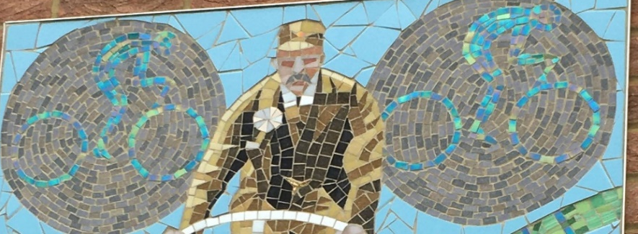

26. What cheers you up every day, and why do you like it?

Well done!
Now enter your quiz - the deadline is the 7th April.
Submit to admin@sandytowncouncil.gov.uk for your chance to win a prize!
Thanks for taking part, good luck, we hope you had fun and we hope you win!

Created by Let’s Get Going CIC

